Welcome to First Grade! My name is Mrs. Bissell and I am very happy to be your teacher this year. I hope you are having a terrific summer and are ready for a great year in first grade! I am so excited about the new school year. We will be learning and doing so many interesting and fun things together!
This year you will become an amazing reader, smart writer, and math master! You will also be a part of an awesome first grade team. Don’t worry if your friends from last year aren’t in our classroom. We do lots of things together as an entire grade, so you will get to see them a lot. Also, you will make so many NEW friends this year!
I want to share a little bit about myself before the year begins. I have been teaching first grade for the past 13 years. I love teaching first grade and I really love that I am teaching in Sharpsville, because it is where I grew up and went to school. I am married to Mr. Bissell, who works as a chemical salesman and owns a maple syrup farm. We have 3 little boys. Jonathan is 7 years old and will be in second grade this year. Jared is 5. He will be in Kindergarten. Benjamin is 20 months old. I will tell you lots of stories about my family throughout the year. I look forward to learning about you and your family, too!
When you come to school, you only need to bring an empty backpack, a lunch (or lunch money), and a smile. I will have folders, notebooks, and a pencil box full of supplies ready for you.
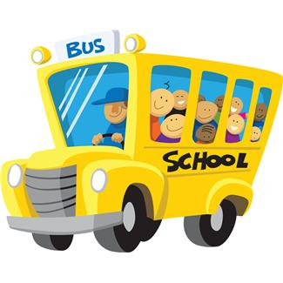
I can’t wait to meet you at Open House on Thursday, August 28 from 5:00-7:00. Be sure to bring your family so they can see your new classroom. I will be waiting for you in room 205. We are going to have a great year!!
See you soon!
Mrs. Bissell

